

*DEPARTMENT OF SOFTWARE*

*ENGINEERING*

***ASSIGNMENT***

**DATE OF SUBMISSION**

**2TH Oct 2021**

* **Course Title:** Object Oriented Programming
* **Section:** II
* **Roll no:** 20SW060
* **Prepared by:** Naveed kk
* **Task lab :** 7

***Submitted to:***

Ma’am Maryam

.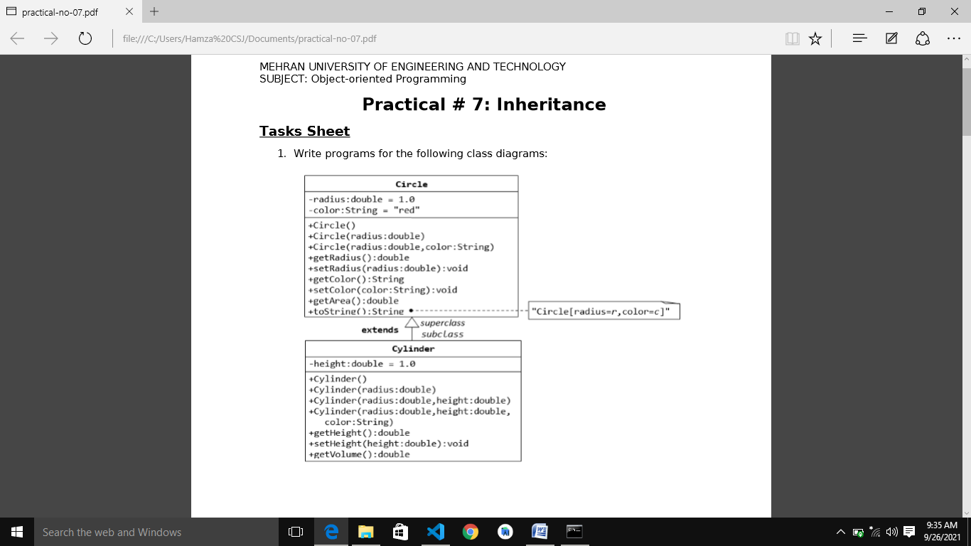

Source Code

class Circle

{

    double radius;

    String color;

    Circle(){}

    Circle(double radius)

    {

        this.radius=radius;

        color="red";

    }

    Circle(double radius , String color)

    {

        radius = this.radius;

        color=this.color;

    }

    public double getRadius()

    {

        return radius;

    }

    public void setRadius(double radius)

    {

        this.radius =radius;

    }

    public String getColor()

    {

        return color;

    }

    public void setColor(String color)

    {

        this.color =color;

    }

    public double getArea()

    {

        return radius*radius*3.14;

    }

    public String toString()

    {

        return radius+" "+color;

    }

}

class Cylinder extends Circle

{

    double height;

    Cylinder(){}

    Cylinder(double radius)

    {

        this.radius=radius;

        color="red";

        height=1.0;

    }

    Cylinder(double radius , double height)

    {

        this.radius = radius;

        this.height=height;

        color="red";

    }

    Cylinder(double radius , double height,String color)

    {

        this.radius =radius;

        this.height=height;

        this.color=color;

    }

    public double getHeight()

    {

        return height;

    }

    public void setHeight(double height)

    {

        this.height=height;

    }

    public double getVolume()

    {

         return (radius*radius*3.14)*height;

    }

    public String toString()

    {

     return "Radius: "+radius+"\nHeight: "+height+"\nColor: "+color;

    }

}

public class Task_1

{

    public static void main(String[] args)

    {

        Cylinder obj=new Cylinder(2.5,3.5,"red");

        System.out.println(obj);

        System.out.println(obj.getVolume());

    }

}

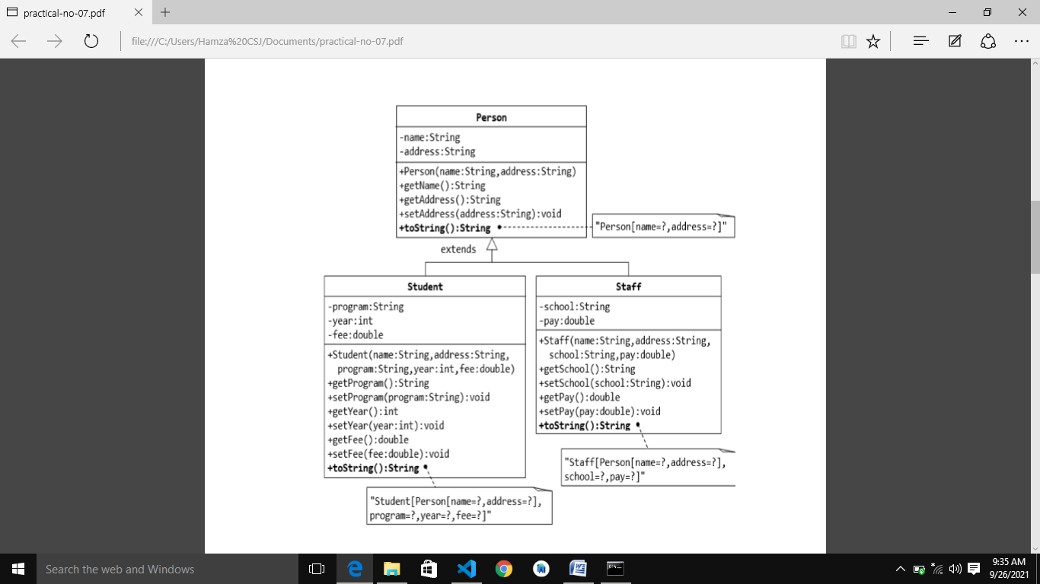

**Source Code**

class person

{

     String name;

     String address;

    person(String name, String address)

    {

        this.name=name;

        this.address=address;

    }

    public String getName()

    {

        return name;

    }

    public String getaddress()

    {

        return address;

    }

    public void setaddress(String address)

    {

        this.address=address;

    }

    public String toString ()

    {

        return "name: "+name+"\nAddress: "+address;

    }

}

class Student extends person

{

    private String program;

    private int year;

    private double fee;

    Student(String name, String address, String program ,int year ,double fee  )

    {

        super(name,address);

        this.program=program;

        this.year=year;

        this.fee= fee;

    }

    public String getprogram()

    {

        return program;

    }

    public void setProgram(String program)

    {

        this.program=program;

    }

    public int getYear()

    {

        return year;

    }

    public void setYear(int year)

    {

        this.year=year;

    }

    public double getFee()

    {

        return fee;

    }

    public void setFee(double fee)

    {

        this.fee=fee;

    }

    public String toString ()

    {

        return "\nname: "+name+"\nAddress: "+address+"\nprogram: "+program+"\nyear: "+year+"\nFee: "+fee;

    }

}

class staff extends person

{

    private String school;

    private double pay;

    staff(String name, String address, String school, double pay)

    {

        super(name,address);

        this.school=school;

        this.pay=pay;

    }

    public void setSchool(String school)

    {

        this.school=school;

    }

    public void setPay(int pay)

    {

        this.pay=pay;

    }

    public int getPay(int pay)

    {

        return pay;

    }

    public String getSchool(String school)

    {

        return school;

    }

    public String toString()

    {

        return "\nname: "+name+"\naddress: "+address+"\nSchool: "+school+"\npay: "+pay;

    }

}

public class Task_2 {

    public static void main(String[] args)

    {

        System.out.print("--------------------Student----------------------");

        Student student= new Student("Naveed","yyyyyyyyyyyy","B.E Software",2020,38000.0);

        System.out.println(student);

        System.out.print("--------------------Staff----------------------");

        staff staf = new staff("Naeem mahoto","yyyyyyyyyyyy","Software",10);

        System.out.println(staf);

    }

}

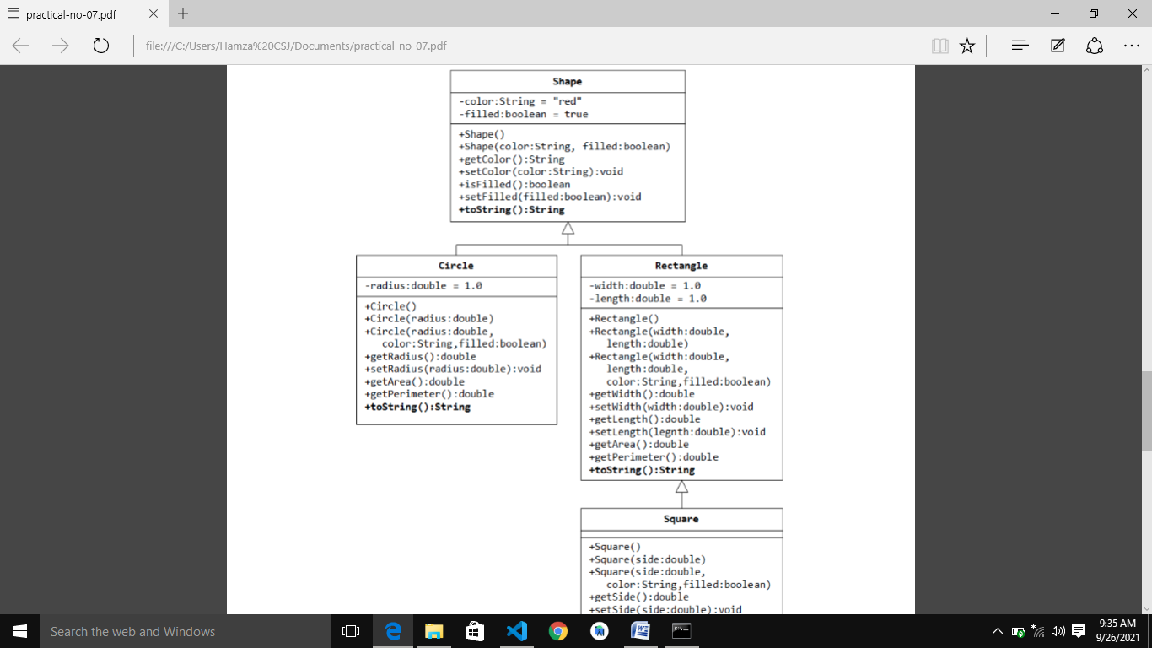

**Source Code:**

class Shape

{

    String color;

    boolean filled;

    Shape(){}

    Shape(String color, boolean filled)

    {

        this.color=color;

        this.filled=filled;

    }

    public String getColor()

    {

        return color;

    }

    public boolean isFill()

    {

        return filled;

    }

    public void setColor(String color)

    {

        this.color=color;

    }

    public void setFilled(boolean filled)

    {

        this.filled=filled;

    }

    public String toString()

    {

        return "color: "+color+"\nFilled: "+filled;

    }

}

class Circle extends Shape

{

    double radius;

    Circle(){}

    Circle(double radius)

    {

        this.radius=radius;

    }

    Circle(double radius,String color, boolean filled)

    {   super(color,filled);

        this.radius=radius;

    }

    public double getRadius()

    {

        return radius;

    }

    public void setRadius(double radius)

    {

        this.radius=radius;

    }

    public double getArea()

    {

        return 3.14*radius*radius;

    }

    public String toString()

    {

        return "color: "+color+"\nfilled: "+filled+"\nRadius: "+radius;

    }

}

class Rectangle extends Shape{

    double width;

    double length;

    Rectangle(){}

    Rectangle(double width,double length)

    {

        this.width=width;

        this.length=length;

    }

    Rectangle(double width,double length,String color,Boolean filled)

    {   super(color,filled);

        this.width=width;

        this.length=length;

    }

    public void setLength(double length)

    {

        this.length=length;

    }

    public void setWidth(double width)

    {

        this.width=width;

    }

    public double getLength()

    {

        return length;

    }

    public double getWidth()

    {

        return width;

    }

    public String toString()

    {

        return "Color: "+color+"\nFilled: "+filled+"\nLength: "+length+"\nWidth: "+width;

    }

}

class Square extends Rectangle{

    double side;

    Square(){}

    Square(double side)

    {

        this.side=side;

    }

    Square(double side,double length, double width,String color,boolean filled)

    {   super(length,width,color,filled);

        this.side=side;

    }

    public double getSide()

    {

        return side;

    }

    public void setSide(double side)

    {

        this.side=side;

    }

    public void setlenght(double length)

    {

        this.length=length;

    }

    public void setWidth(double width)

    {

        this.width=width;

    }

    public String toString()

    {

        return "Color: "+color+"\nfilled: "+filled+"\nSide: "+side+"\n Length: "+length+"\nWidth: "+width;

    }

}

public class Task_3 {

    public static void main(String[] args)

    {

        System.out.println("------------------Circle--------------------------");

        Circle Cir=new Circle(1.8,"Red",true);

        System.out.println(Cir);

        System.out.println("------------------Rectangle--------------------------");

        Rectangle Rect=new Rectangle(3.8,2.5,"Red",true);

        System.out.println(Rect);

        System.out.println("------------------Square--------------------------");

        Square Sqr=new Square(2.5,3.5,2.7,"Red",true);

        System.out.println(Sqr);

    }

}

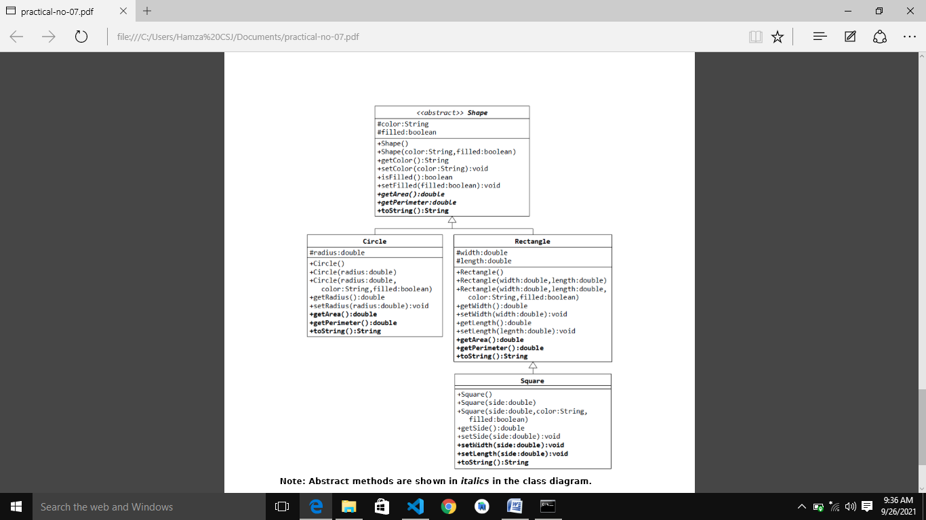

**Source Code:**

abstract class Shape

{

    String color;

    boolean filled;

    Shape(){}

    Shape(String color, boolean filled)

    {

        this.color=color;

        this.filled=filled;

    }

    public String getColor()

    {

        return color;

    }

    public boolean isFill()

    {

        return filled;

    }

    public void setColor(String color)

    {

        this.color=color;

    }

    public void setFilled(boolean filled)

    {

        this.filled=filled;

    }

   abstract public String toString();

   abstract public double getArea();

}

class Circle extends Shape

{

    double radius;

    Circle(){}

    Circle(double radius)

    {

        this.radius=radius;

    }

    Circle(double radius,String color, boolean filled)

    {   super(color,filled);

        this.radius=radius;

    }

    public double getRadius()

    {

        return radius;

    }

    public void setRadius(double radius)

    {

        this.radius=radius;

    }

    public double getArea() //implementation of abstract method

    {

        return 3.14*radius*radius;

    }

    public String toString()    //implementation of abstract method

    {

        return "color: "+color+"\nfilled: "+filled+"\nRadius: "+radius;

    }

}

class Rectangle extends Shape{

    double width;

    double length;

    Rectangle(){}

    Rectangle(double width,double length)

    {

        this.width=width;

        this.length=length;

    }

    Rectangle(double width,double length,String color,Boolean filled)

    {   super(color,filled);

        this.width=width;

        this.length=length;

    }

    public void setLength(double length)

    {

        this.length=length;

    }

    public void setWidth(double width)

    {

        this.width=width;

    }

    public double getLength()

    {

        return length;

    }

    public double getWidth()

    {

        return width;

    }

    public String toString()        //implementation of abstract method

    {

        return "Color: "+color+"\nFilled: "+filled+"\nLength: "+length+"\nWidth: "+width;

    }

    public double getArea(){

        return length*width;

    }

}

class Square extends Rectangle{

    double side;

    Square(){}

    Square(double side)

    {

        this.side=side;

    }

    Square(double side,double length, double width,String color,boolean filled)

    {   super(length,width,color,filled);

        this.side=side;

    }

    public double getSide()

    {

        return side;

    }

    public void setSide(double side)

    {

        this.side=side;

    }

    public void setlenght(double length)

    {

        this.length=length;

    }

    public void setWidth(double width)

    {

        this.width=width;

    }

    public String toString()

    {

        return "Color: "+color+"\nfilled: "+filled+"\nSide: "+side+"\n Length: "+length+"\nWidth: "+width;

    }

}

public class Task_4 {

    public static void main(String[] args) {

        System.out.println("------------------Circle--------------------------");

        Circle Cir=new Circle(1.8,"Red",true);

        System.out.println(Cir);

        System.out.println("------------------Rectangle--------------------------");

        Rectangle Rect=new Rectangle(3.8,2.5,"Red",true);

        System.out.println(Rect);

        System.out.println("------------------Square--------------------------");

        Square Sqr=new Square(2.5,3.5,2.7,"Red",true);

        System.out.println(Sqr);

    }

}